



TO SUPPLY LEFTOVER FOOD TO POOR
SALESFORCE PROJECT DOCUMENT
SUBMITTED BY:
JEEVITHAN.Y
BACHELOR OF TECHNOLOGY
IN
COMPUTER SCIENCE AND BUSINESS SYSTEM
M.KUMARASAMY COLLEGE OF ENGINEERING (Autonomous)
KARUR - 639 113
JULY 2025

To Supply Leftover Food to Poor

Project Overview:
FoodConnect is a Salesforce-based CRM solution developed to tackle the dual challenges of food wastage and hunger. Leveraging the Salesforce platform, it collects surplus food from sources such as restaurants, event halls, and households, and ensures it is systematically redistributed to NGOs and underprivileged communities. The system manages multiple user roles—donors, NGOs, volunteers, and admins—by offering tailored features within a secure, centralized environment.
This solution employs custom objects, powerful automation tools like Flows and Process Builder, and robust analytics through reports and dashboards to monitor every aspect of the food redistribution cycle—from donor registration to final food delivery. Real-time tracking, role-specific access, and streamlined communication between users make coordination seamless. Automated workflows, location-based volunteer assignments, and strong data validation reduce manual work and improve process efficiency.
By combining the adaptability of Salesforce with a social mission, FoodConnect brings an innovative approach to combating food insecurity through digital transformation.
Key Features:
- Unified platform for registering food sources, donations, and volunteers
- Automated task creation and assignment based on availability and proximity
- Sharing rules driven by geographic distance to optimize delivery
- Custom reports and dashboards for tracking performance and activities
- Role-based permissions to secure and streamline data access
- Architecture supporting future integrations like AI or chatbots

1

Business Need:
The main requirement is to reduce food wastage while aiding the hungry, through automation, effective monitoring, and scalable coordination between food contributors, NGOs, and volunteers.
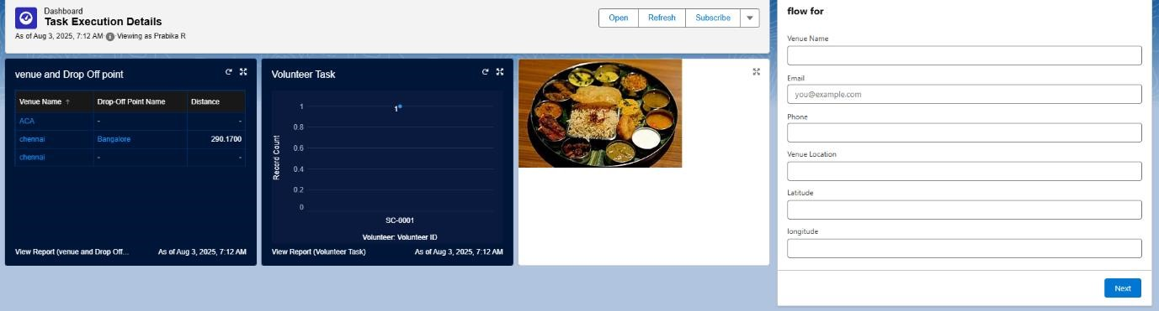

Fig 1 : Home Page
Objectives:
The core mission of the FoodConnect CRM is to digitize and streamline the surplus food collection and delivery workflow. It connects food donors, NGOs, volunteers, and admins within a unified Salesforce system, facilitating effective tracking and delivery operations. By automating processes, the system enhances collaboration and speeds up response times.
A key focus is to automate important actions such as assigning volunteers, creating tasks, and updating delivery statuses. Using Salesforce automation tools like Flows, Process Builder, and Approval Processes, the system ensures that volunteers are selected based on location and availability—enhancing efficiency and accuracy.
With role-based permissions, each user can only access the data relevant to their role. Real-time reports and dashboards offer visibility into donation progress, volunteer participation, and delivery timelines—enabling faster decisions and greater transparency.
In summary, FoodConnect’s objective is to cut down on food waste and serve communities by simplifying and managing the logistics of food donation.

2

Phase 1: Requirement Analysis and Planning

In the initial phase, detailed requirements were collected by engaging with expected users like donors, NGOs, volunteers, and administrators. Through meetings and discussions, their expectations and common problems were explored, helping define the project's goal: to build a unified, automated Salesforce CRM that connects all users and streamlines food distribution.

Key user needs identified during this phase include:

Donors needed a fast way to log food availability

NGOs required timely updates on food offers

Volunteers needed tasks based on their current location

Admins demanded tools to track and manage end-to-end processes

From these needs, the system’s features were finalized. The scope involved automating tasks and volunteer allocation, tracking food flow, enforcing data security with access roles, and implementing real-time analytics.

Custom objects like Venue, Drop-Off Point, Volunteer, Task, and Execution Detail were created. These were linked using Master-Detail and Lookup fields. Security was implemented via Role Hierarchies, Public Groups, and Sharing Rules to ensure correct data visibility per user.
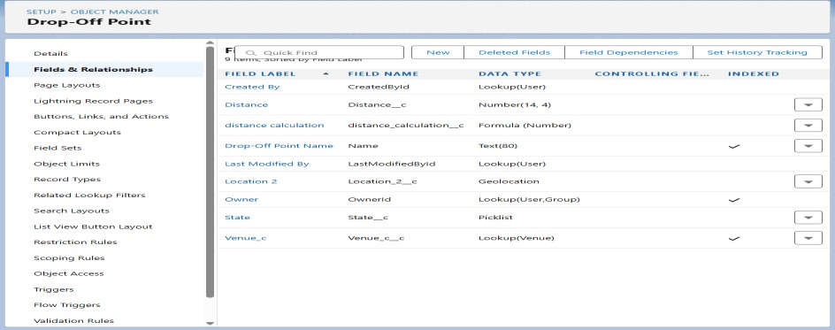
Fig 2 : Drop off Point Custom objects

3
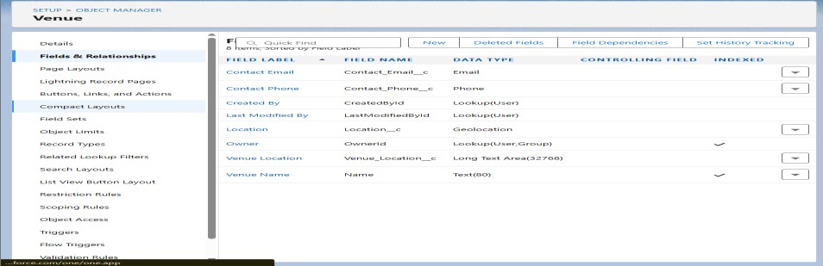

Fig 3 : Venue Custom objects
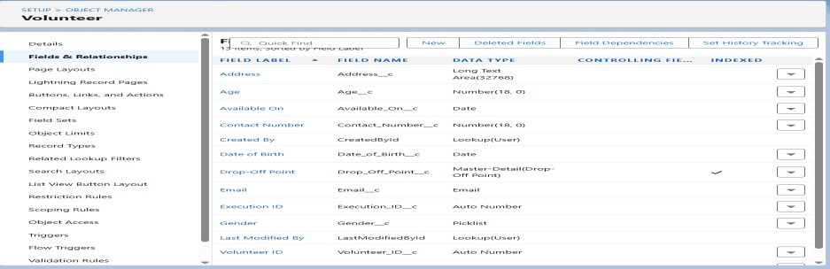

Fig 4: Volunteer Custom objects
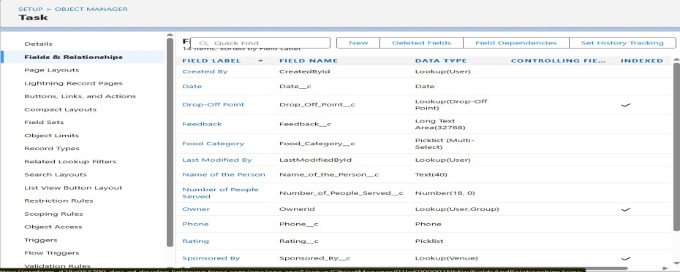

Fig 5 : Task Custom objects

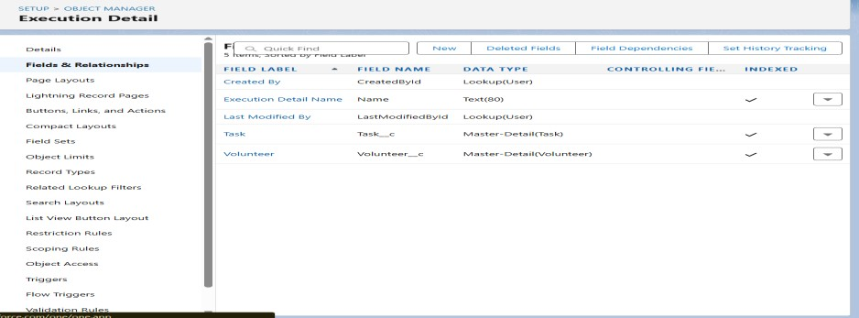
Fig 6 : Execution Detail Custom objects

4

Phase 2: Salesforce Development - Backend & Configurations
In this phase, the team concentrated on developing the core functionalities of the FoodConnect application using Salesforce’s backend configuration tools. Based on the planning outlined in Phase 1, the team initiated development by setting up a Salesforce Developer Org. The environment was prepared to support the creation of custom objects, automation workflows, and validation mechanisms essential for efficient food donation and delivery processes.

Custom objects such as Venue, Drop-Off Point, Volunteer, Task, and Execution Detail were configured with appropriate fields and relationships. Validation rules were established to maintain data reliability—for example, ensuring that donation expiry dates are set in the future, food quantities are entered as positive values, and that mandatory fields are properly filled. These validations helped preserve the integrity and accuracy of the data at all stages.

Automation played a crucial role during this development phase. Salesforce Flows were implemented to automatically generate task records and allocate volunteers depending on the donation location. Process Builder and Approval Processes were employed to manage notifications and streamline approval workflows. For scenarios requiring advanced control, Apex triggers were developed to implement backend logic—such as computing and storing the distance between venues and drop-off points to support conditional sharing rules.

The team also prioritized security and system efficiency. Field history tracking was enabled for key fields like task status and volunteer assignment to allow for better monitoring and auditing. Both Lookup and Master-Detail relationships were used to maintain data consistency and enforce logical connections between records. This backend development phase ensured that the FoodConnect system was fully functional, well-automated, and prepared to support the user interface in the subsequent stage.

5
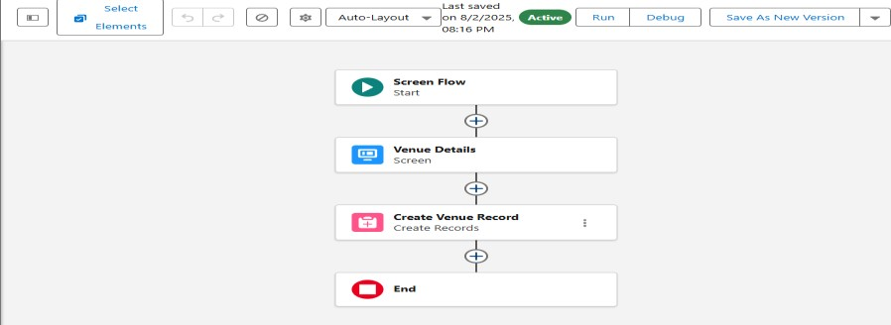

Fig 7 : Screen Flow
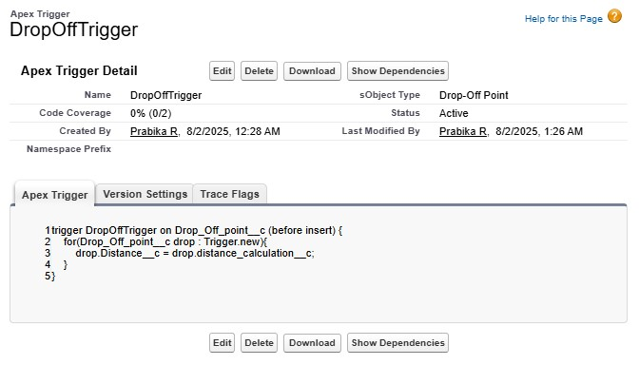
Fig 8 : Apex Trigger

Phase 3: UI/UX Development & Customization
In this phase, our focus was on crafting an intuitive and user-friendly interface suitable for all categories of users—donors, NGOs, volunteers, and administrators. Leveraging Salesforce Lightning tools, we designed customized layouts and streamlined navigation to ensure users could interact with the system smoothly and accomplish their tasks without confusion.
We built a dedicated Lightning App named FoodConnect using the App Manager. This app served as a centralized hub, allowing access to all essential tabs and records. Custom tabs were created for objects such as Venue, Drop-Off Point, Volunteer, Task, and Execution Detail, enabling users to manage and view records in an organized and systematic manner.

6
Page Layouts were tailored to user roles, ensuring each user viewed only the fields and sections relevant to their tasks. Dynamic Forms were used to show or hide fields based on record data, improving clarity and reducing clutter. Lightning Record Pages were built using the Lightning App Builder, incorporating components like related lists, flow screens, and charts.
To enhance user experience, dashboards and reports were embedded to provide real-time insights into donations, volunteer activity, and food distribution. A Flow-based form simplified venue creation, and optional Lightning Web Components (LWC) were explored to add a modern, responsive interface. This phase ensured the system was both functional and user-friendly.

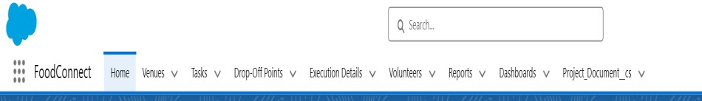

Fig 9 : App Builder

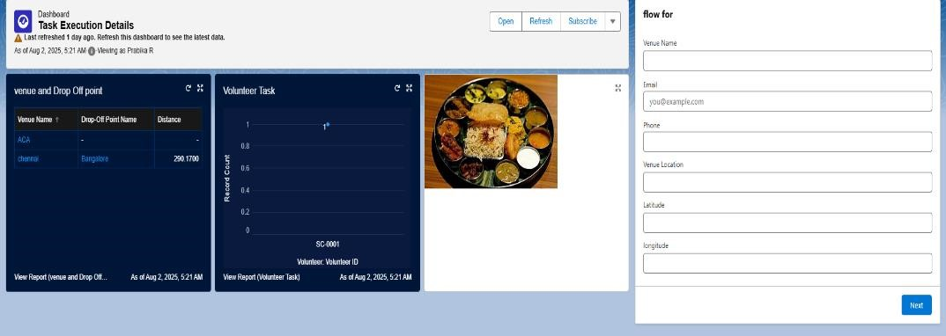
Fig 10 : App Page

Phase 4: Data Migration, Testing & Security
During this phase, we focused on building a user-centric interface tailored to the needs of donors, NGOs, volunteers, and administrators. Using Salesforce Lightning tools, we designed a structured and intuitive UI to ensure smooth navigation and ease of use. Page Layouts were customized based on user roles so that individuals only saw fields relevant to their responsibilities, improving both usability and data security.

7
Dynamic Forms were used to control field visibility based on record data, reducing clutter and enhancing clarity. Lightning Record Pages were configured with the App Builder to include components like related lists, flow screens, and charts—giving users a complete view of records without needing to switch screens.

To improve real-time decision-making, dashboards and reports were embedded into the interface, offering instant insights into donation status, volunteer activity, and food distribution coverage. A Flow-based form was created to streamline the venue registration process, making it more guided and error-free. Additionally, Lightning Web Components (LWC) were explored to add modern, interactive elements, ensuring the system was both functional and visually engaging.

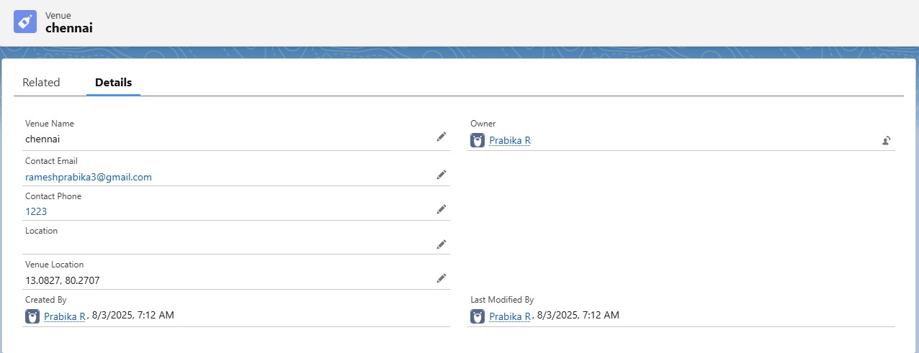

Fig 11 : Testing

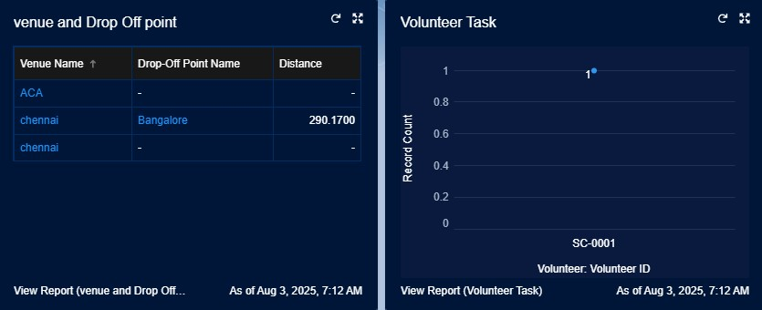
Fig 12 : Data
8

Phase 5: Deployment, Documentation & Maintenance

The final phase of the FoodConnect project emphasized deploying the application into the production environment, creating comprehensive documentation for future reference, and establishing long-term maintenance procedures. This phase was essential to ensure that the system would function effectively in real-world conditions and could be supported and enhanced over time.

To manage deployment, the Salesforce Change Set feature was used to transfer metadata elements—such as custom objects, fields, flows, validation rules, and dashboards—from the development sandbox to the production org. Prior to deployment, all components were thoroughly reviewed and tested to minimize the risk of errors. Post-deployment activities included activating necessary flows, adjusting permission sets, and validating user profiles to confirm the application was fully operational in the live environment.

Extensive documentation was created to assist both users and administrators in understanding the structure, functionality, and logic of the system. This included detailed explanations of custom objects, data relationships, automation tools, user roles, and testing procedures. To make the documentation more practical, screenshots were incorporated to illustrate page layouts, dashboard views, flow designs, and reporting components. This guide serves as a helpful reference for future developers, testers, and system administrators.

In order to ensure continued system performance, a basic maintenance framework was established. Administrators will regularly review dashboards, monitor flow executions and Apex trigger operations, and identify any issues with failed automation processes. Debug logs and error alert emails will be used to quickly detect and resolve problems. Additionally, user feedback will be actively gathered to inform future upgrades and enhancements, ensuring the platform continues to evolve based on real-world needs and user experience.

Conclusion
The FoodConnect project effectively harnessed the power of the Salesforce platform to build an intelligent, automated, and user-friendly system for managing surplus food distribution. By integrating donors, NGOs, and volunteers into a unified CRM solution, the project brought greater organization, efficiency, and traceability to the food donation process.
9
Core functionalities such as automated volunteer assignments, real-time status tracking, and role-based data access significantly reduced manual intervention and enhanced coordination among all participants. Additionally, the integration of reports and dashboards delivered meaningful insights for monitoring activities and guiding data-driven decisions.
Beyond minimizing food waste, the system ensured that surplus food was delivered to those in need promptly and reliably. It promoted transparency, accountability, and meaningful social impact by maximizing the effective use of available resources.
In conclusion, FoodConnect demonstrated how digital platforms like Salesforce can address real-world challenges and positively impact society by simplifying and optimizing critical operations such as food collection and distribution.

Future Enhancements
Though FoodConnect covers the core needs of food donation management, a few future upgrades can make it more user-friendly and efficient:
- Chatbot for Donation Tracking:
A chatbot can help users like donors and NGOs track donations in real-time through a simple chat interface. This avoids navigating multiple pages and improves user experience.
- AI-Based Volunteer Route Optimization:
Using AI, the system can suggest the best delivery routes for volunteers by checking location, traffic, and urgency. This saves time, fuel, and ensures faster deliveries.
- Mobile App Support using Salesforce Mobile SDK:
A mobile app can be built using the Salesforce Mobile SDK. It will let volunteers view tasks, update delivery status, and get notifications on their phones.
These additions will make FoodConnect smarter, more engaging, and easier to use for everyone involved.

10

